A1
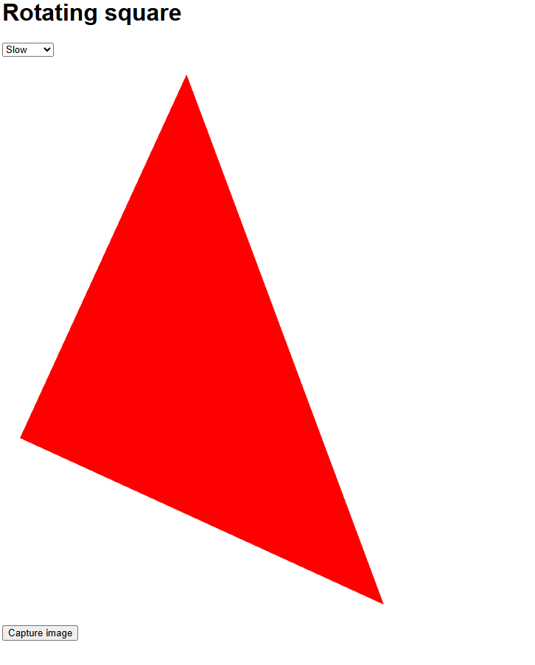
changing num_strip_vertices in gl.drawArrays(gl.TRIANGLE_STRIP, 0, num_strip_vertices) to 3 (A1.1) makes gl.drawArrays only read the first 3 coordinates from the vertices array(A1.2), making the shape change from a square into a triangle

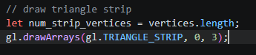
A1.1:

A1.2:

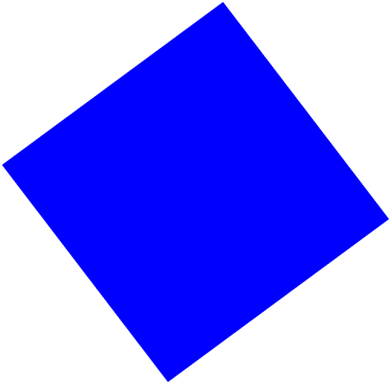
A2
by changing the third value in gl_FragColor to 1.0 and the first value to 0.0 the square’s colour changed to blue

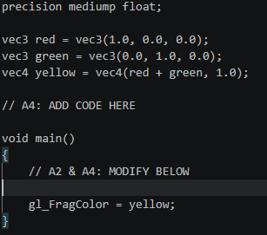
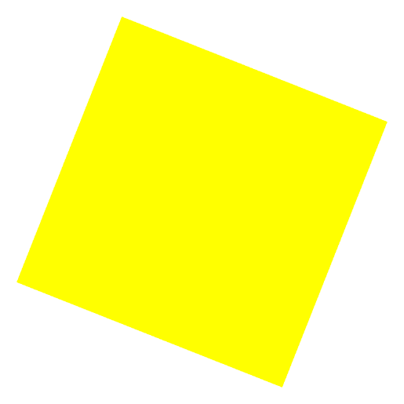

I defined red green and yellow, red and green as vec3 as they don’t need them to contain an opaque value and then I defined yellow as a vec4 adding red and green inside of it to create the colour yellow then adding the opaque value on the end, then finally changed gl_FragColour to be set to yellow.

